
Source Analysis
Homework Task Four

Question/Answer Booklet

ATAR Name:
MODERN
HISTORY
Unit 1
Capitalism – The American Experience 1907-1941

Source Booklet
Source 1: Chicago Tribune, 1937

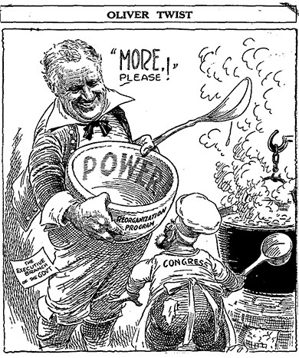

Source 2: ‘The New Deal in Review 1936-1940’, in New Republic, 20 May 1940.

“The New Deal has clearly done far more for the general welfare of the country and its citizens than any administration in the previous history of the nation. Its relief for the underprivileged in city and country has been indispensable. Without this relief an appalling amount of misery would have resulted…In addition, the New Deal has accomplished much of permanent benefit to the nation.”

Source 3: C.P. Hill, Franklin Roosevelt, 1966

“What did the New Deal achieve…It certainly did not cure the Depression. And many economists have maintained that on balance it did not even do much to help American business to recover.”

- Explain the historical context of Source 1. Include the relevant events, people and ideas depicted or represented in the source. (4 marks)

Hint: what, when, cause, effect? (1 mark each) Focus on what is in the source and explain the relevance/significance. What is the event/idea the source is directly related to, rather than the source itself? How did this affect society, what was the impact?

___________________________________________________________________________________________________________________________________________________________________________________________________________________________________________________________________________________________________________________________________________________________________________________________________________________________________________________________________________________________________________________________________________________________________________________________________________________________________________________________________________________________________________________________________________________________________________________________________________________________________________________________________________________________________________________________________________________________________________________________________________________________________________________________________________

- Identify and account for the authors’ perspectives in Sources 2 and 3 in relation to the attitudes regarding changes in domestic economic policies during the period of study. (6 marks)

Hint: Consider source 3 and source 4 separately. What is the viewpoint of the creator? What influenced the author/illustrator to create this? What were they hoping to achieve and why? Articulate the perspective of source 3 (1 mark). Account for author’s perspective in source 3 (bias, motives, time, place, purpose) (2 marks). Articulate the perspective of source 4 (1 mark). Account for author’s perspective in source 4 (bias, motives, time, place, purpose) (2 marks).

___________________________________________________________________________________________________________________________________________________________________________________________________________________________________________________________________________________________________________________________________________________________________________________________________________________________________________________________________________________________________________________________________________________________________________________________________________________________________________________________________________________________________________________________________________________________________________________________________________________________________________________________________________________________________________________________________________________________________________________________________________________________________________________________________________
__________________________________________________________________________________________________________________________________________________________________________________________________________________________________________________________________________________________________________________________________________________________________________________________________________________________________________________________________________________________________________________________________________________________________________________________________________________________________________________________________________________________________________________
- Evaluate the extent to which the three sources give an accurate insight into attitudes regarding changes in domestic economic policies during the period of study. (6 marks)

Hint: Make a judgement on how the four sources teach us about attitudes regarding changes in domestic economic policies during the period of study. Articulate the different attitudes of change that are shown (2 marks). Identify attitudes that have been omitted (1 mark). Evaluate the extent to which the sources reflect the different attitudes regarding changes in domestic economic policies during the period of study (3 marks).

________________________________________________________________________________________________________________________________________________________________________________________________________________________________________________________________________________________________________________________________________________________________________________________________________________________________________________________________________________________________________________________________________________________________________________________________________________________________________________________________________________________________________________________________________________________________________________________________________________________________________________________________________________________________________________________________________________________________________________________________________________________________________________________________________________________________________________________________________________________________________________________________________________________________________________________________________________________________________________________________________________________________________________________________________________________________________________________________________________________________________________________________________________________________________________________________________________________________________________________________________________________________

Marking key:
- Explain the historical context of Source 1.
Description | Marks
Identifies the focus of the source | 1
Outlines the causes or events that led to the focus of the source | 1
Provides specific details for the focus of the source, dates/events/people/place/ideas | 1–2
Total | /4
Note: This question is concerned with the historical context in which the source is located. The answer must concentrate on what is in the source and explain the relevance/significance.

- Identify and account for the authors’ perspectives in Sources 2 and 3 in relation to the attitudes regarding changes in domestic economic policies during the period of study.
Description | Marks
Articulates the perspective of Source 2 | 1
Articulates the perspective of Source 3 | 1
Analyses of the perspectives in relation to the question asked. This may include discussion of:  • motives  • bias  • time  • place  • purpose | 1–4
Total | /6
Note: The response should:
- analyse the perspectives of the sources in terms of the theme/force
- articulate the perspectives from which the sources were constructed or analyse reasons for the perspective (purpose/motive/place/and time)
- use evidence of the perspective from the source
- identify how the author shows the perspective in the source.

- Evaluate the extent to which the three sources give an accurate insight into attitudes regarding changes in domestic economic policies during the period of study.
Description | Marks
Articulates the different aspects of change that are shown. | 2
Identifies aspects of change that have been omitted. | 1
Evaluates the extent to which the sources reflect the significance of the changes depicted in the sources in terms of the changes in domestic economic policies during the period of study. | 1–3
Total | /6
Note: The response should:
- focus on what the sources say about change within the context studied, and why it may have been significant to highlight this
- include the implication/impact of these changes
- include the student’s own knowledge of the time period to support their point of view.

